Suspension bridge

MATH203i-Diffrential Equations

Under the supervision of

Dr. Ethar Ahmed

Made by

NAME: ID:

|  |  |
| --- | --- |
| Michael Wagdy Wahib | **211001776** |
| Youssef Hassan Abdelmaksoud | **211002056** |
| Yassin Saad Elasfar | **211002150** |
| Islam Nasr Atwan | **211001735** |
| Abdallah Khaled gadallah | **211001978** |
| Philopater ayman boles | **211001925** |

**TABLE OF CONTENTS**

Chapter Page

TABLE OF CONTENTS........................................................................................................................... 2

LIST OF FIGURES.................................................................................................................................. 3

ABSTRACT............................................................................................................................................ 4

SECTION I: Introduction...................................................................................................................... 5

SECTION II: Background and Literature Review.................................................................................. 6

Types of suspension bridge:…………………………………………………………………………………………………...

History of suspension bridge:………………………………………………………………………………………………….

SECTION III: Models and differential equations ……………………………………………………………………………. 11

SECTION IV: METHODOLOGY............................................................................................................ 13

SECTION V: RESULTS ........................................................................................................................ 16

SECTION VI: CONCLUSION ................................................................................................................. 18

REFERENCES...................................................................................................................................... 19

Keywords........................................................................................................................................... 21

Appendices........................................................................................................................................ 22

**LIST OF FIGURES CAPTION**

1. Figure (1): The two main forces of a suspension bridge are tension in the cables and compression in the towers.
2. Figure (2): Simple suspension bridge:
3. Figure (3): Suspended – deck suspension bridge:
4. Figure (4): Under spanned suspension bridge:
5. Figure (5): Stressed ribbon bridge:
6. Figure (6): Self-anchored suspension bridge:
7. Figure (7): James Finley Bridge

**Abstract**

A bridge type known as a suspension bridge has its top suspended by vertical suspenders and suspension cables. Main suspension cables, primary towers, strengthening beams and struts, and the main structural elements of a suspension bridge system are cable anchorages at each end of the bridge. Vertical suspenders sustain the weight of the deck and the traffic load, while the main cables are stretched between towers and eventually connect to the anchorage or the bridge itself.

The superstructures of suspension bridges are constructed utilizing the cable erection technique similarly to other cable-supported bridges. The primary load-bearing parts are the main cables, which are tension members made of high-strength steel. Buckling is not a concern because the main cable's full cross-section is highly effective at moving weights. As a result, the deadweight of the bridge can be decreased, enabling a longer span. Suspension bridges are also more lovely than other types of bridges. The structural elements, categorization, technique of analysis, and construction process of suspension bridges are all covered in this chapter. The differential equation will be used through Python code The code to apply it in a general suspended bridge.

SECTION I: Introduction

One of the most well-liked bridge types is the suspension bridge. The bridge deck's weight is divided between the two towers via a cable support system. The compression forces generated by the piers, which extend all the way to the earth, are changed from tension forces in the cables.” Because the deck is hung in the air, care must be taken to ensure that it does not move excessively under loading. The deck therefore must be either heavy or stiff or both [1]. As Shown.

(Fig.1)( tension in the cables and compression in the towers)

The suspenders, or smaller cables, run from the bridge deck up to the main supporting cables. Their responsibility is to use the primary supporting cables to carry the weight of the deck to the towers. The beautiful cable arcs that connect the towers to the anchorages at each end of the bridge serve as the major supporting cables.

SECTION II: Background and Literature Review

## Types of suspension bridge:

A type of bridge called a suspension bridge is one that relies more on tension than compression. Normally, the main cables that are attached to the towers at both ends of the bridge suspend it. Towers were previously excluded from suspension bridges because they were constructed for brief durations. 14 of the longest bridges in the world today are suspension bridges, though. Today, a variety of suspension bridge types are available, as follows:

1. Simple suspension bridge.

One of the first types of suspension bridges, it is often constructed as a footbridge. This type of bridge features a flexible deck that is supported by cables and anchored to the ground.

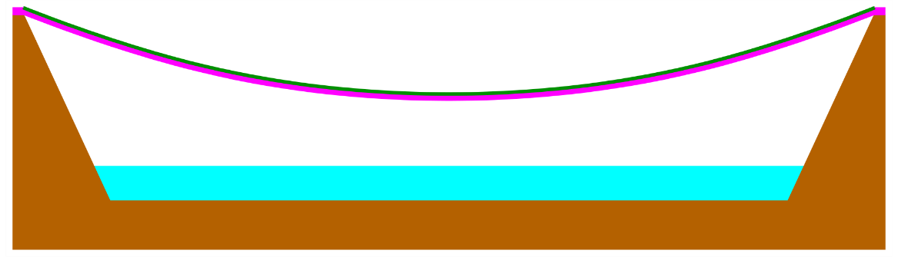

(Fig.2) Simple suspension bridge

1. Suspended – deck suspension bridge:

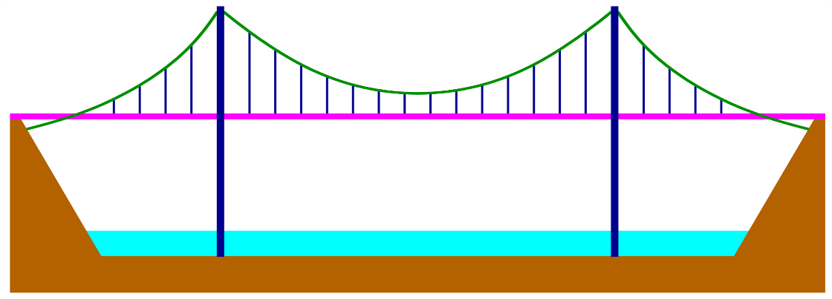This type of suspension bridge uses suspenders to join the main cables to the reinforced deck. For light rail and areas with heavy traffic, this design is suitable.

(Fig.3)Suspended – deck suspension bridge

1. Under spanned suspension bridge:

This kind of suspension bridge's main cables are hidden beneath the deck. Cables are secured to the ground. Only a few suspension bridges have been constructed this way due of the deck's weakness



(Fig.4) Under spanned suspension bridge

1. Stressed ribbon bridge:

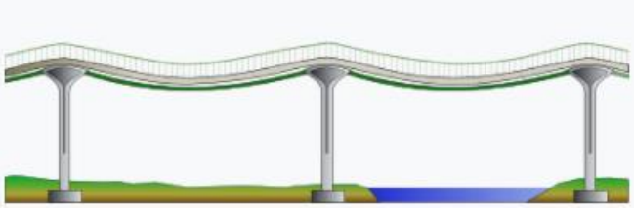The deck of this suspension bridge sits on the main cables; however, it is stiff rather than flexible.

(Fig.5) Stressed ribbon bridge

1. Self-anchored suspension bridge:

A modern descendant of the suspension bridge that combines components of a cable-stayed bridge. The major wires are secured to the decks' ends.

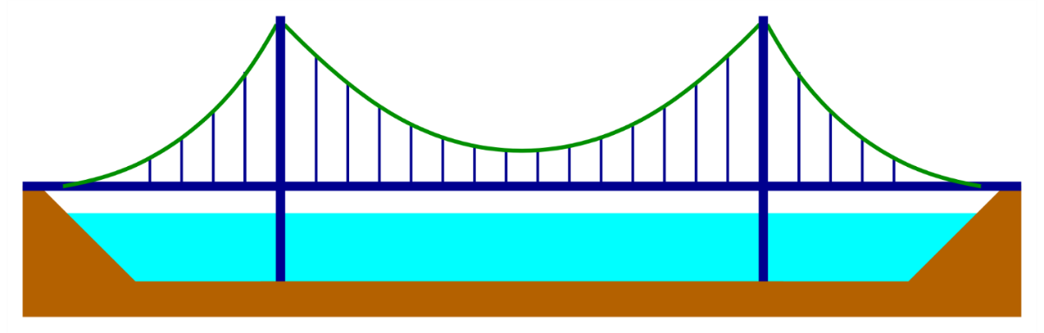

(Fig.6) Self-anchored suspension bridge

As shown in [2]

## 

## The suspension bridge's History:

Since ancient times, suspension bridges have existed. But they were not the product of Western science and technology. They seem to have come from China and the Americas. European explorers and travelers saw the structures, and their descriptions prompted curiosity about the suspending theory.

The first metal suspension bridges were built in China. Iron chains that were suspended from the ground over gorges or rivers were used to construct these bridges. Wooden planks that were immediately attached to the chains served as the decks. At least one of the sixteenth-century bridges is still in operation.

In South America, suspension bridges were made of non-metallic, woven-fiber structures that were used by people. In the middle of the seventeenth century, these structures were first referenced in the Western world. In the west, temporary military bridges first employed the suspension principle [3].

James Finley constructed the first chain-supported suspension bridge in America in 1801. During the early 1800s, Finley constructed numerous small suspension bridges in Pennsylvania after patenting the concept. One of Finley's design's many novel elements was the use of a straightforward 8-point stiffening system for the deck and an obvious but remarkably efficient method for calculating the sag of the chains. The first chain-built suspension bridge in America was built by James Finley in 1801. In the early 1800s, Finley built several tiny suspension bridges in Pennsylvania after receiving a patent for the concept. The use of a simple stiffening system for the deck and a simple but highly effective method for determining chain sag were two of Finley's design's many novel features.

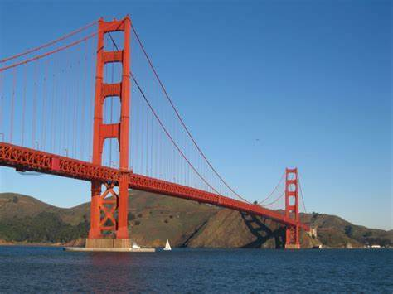

(Fig.7) James Finley Bridge

**SECTION III: Models and differential equations**

## Simple suspension bridge:

The catenary curve resembles a U and appears to be an arch with a parabolic shape; however, it is not a parabola. The curve can be seen in the design of some types of arches as well as in a cross-section of the catenoid, which is the shape that a soap film with two parallel circular rings around it assumes.

The equation of a catenary in Cartesian coordinates has the form:

$$y= acosh\left(\frac{x}{a}\right)= \frac{a}{2} ( e^{\frac{x}{a}}+ e^{-\frac{x}{a}} )$$

*where x is measured from the lowest position, and cosh is the hyperbolic cosine function. Since changing the parameter, a result in a consistent scaling of the curve, all catenary curves are comparable to one another.*

## Self-anchored suspension bridge:

The Self-anchored suspension bridge split to two differential equation one for one for the cable-Stayed and one for the suspension bridge:

1-Differential equation of the **cable-stayed** interval:

For the cable cable-stayed interval $x∈\left[x_{1},x_{2}\right]∪[x_{3},x_{4}]$,the balance equation is:

T = C (C represents the constant), $\cos\left(α+β\right)- \frac{d}{dx}\left(N_{x}+\frac{1}{2}EA_{b}v_{b}^{'2}\right)=0$,

where ( $α+β)$ is the angle between the stay cable and the x-axis positive direction after deformation.

2-Differential equation of the **suspension** interval:

For the suspension interval interval $x∈[x_{3},x_{4}]$,the balance equation is:

$$\frac{d}{dx}\left[Tcos\left(θ+φ\right)\right]+s\left(x\right)\frac{u_{b}-u_{c}}{\sqrt{{\left[h\left(x\right)+v_{b}-v_{c}\right]}^{2}}+{\left(v_{b}-u_{c}\right)}^{2}}=0,$$

$$\frac{d}{dx}\left[Tcos\left(θ+φ\right)\right]+s\left(x\right)\frac{h\left(x\right)+v_{b}-v_{c}}{\sqrt{{\left[h\left(x\right)+v_{b}-v_{c}\right]}^{2}}+{\left(v_{b}-u_{c}\right)}^{2}}=0,$$

$$\frac{d}{dx}\left(N_{x}+\frac{1}{2}EA_{b}v_{b}^{'2}\right)-s\left(x\right)\frac{u_{b}-u_{c}}{\sqrt{{\left[h\left(x\right)+v_{b}-v_{c}\right]}^{2}}+{\left(v_{b}-u_{c}\right)}^{2}}=0,$$

$$\frac{d^{2}}{dx^{2}}M_{x}+\frac{d}{dx}\left(N_{x}v_{b}^{'}\right)+p+q-s(x)\frac{h\left(x\right)+v_{b}-v_{c}}{\sqrt{{\left[h\left(x\right)+v_{b}-v_{c}\right]}^{2}}+{\left(v_{b}-u_{c}\right)}^{2}}=0.$$

Both the suspension interval's differential equations and the cable-stayed interval's differential equations are fairly challenging to solve. Setting a family function of displacement for each parameter that satisfies the boundary conditions and approaches an approximate solution by employing the notion of stationary potential energy is a straightforward way to solve the equations, but this is not the focus of this study. This paper aims to show that the continuum approach allows for a relatively accurate description of the static behaviour of a self-anchored cable-stayed suspension bridge under vertical load. In order to make the aforementioned equations simpler, additional assumptions are made [6].

**SECTION IV: METHODOLOGY**

Construction of the suspension bridge is conducted in the following order:

*The bridge deck is created last, followed by the main cables and towers. Depending on the project, it could take a few months, a year, or even decades to finish the construction.

*The concrete tower base is built following the excavation. After the foundation is laid, the towers are erected using single or multiple high strength reinforced concrete, steel, or stone columns as their structural support. Later, anchorages that offer security to the cable ends are constructed.

*The main cables are strung between the towers and secured at the ends once the anchorages are finished. High tensile strength twisted steel wires are used to make the cable. The main wires are then connected to the suspenders, which connect the deck to them.

*The construction of the deck begins when the suspenders are connected. To keep the load conditions in towers always balanced, the deck structure must move equally in both directions. Base is applied to the deck once it is finished .

The differential equation of a general suspension bridge

$$mx^{``}\left(t\right)+cx`\left(t\right)+kx\left(t\right)=F(t)$$

In this equation, x represents the displacement of the bridge deck, t represents time, m is the mass of the bridge deck, k is the stiffness of the bridge's cables and other structural elements, c is the damping coefficient, and F(t) is the external force acting on the bridge deck at time t. The second derivative of x with respect to t [x``(t)] represents the acceleration of the bridge deck, and the first derivative of x with respect to t [x`(t)] represents the velocity of the bridge deck.

mass * acceleration + stiffness * displacement + damping * velocity = external force

There are several methods we can use to find a solution, such as separation of variables, integration factors, or series solutions.  
To solve the differential equation using separation of variables, we can rewrite it as follows:

mx``(t) + cx`(t) + kx(t) = F(t)

Then, we can divide both sides by x(t):

(mx``(t) + cx`(t) + kx(t))/x(t) = F(t)/x(t)

Next, we can rewrite the left-hand side as a derivative:

d/dt [(mx`(t) + cx(t))/x(t)] = F(t)/x(t)

Then, we can integrate both sides with respect to t:

(mx`(t) + cx(t))/x(t) = ∫ F(t)/x(t) dt + C

Where C is a constant of integration.

Finally, we can solve for x(t):

x(t) = (mx`(t) + cx(t))/[∫ F(t)/x(t) dt + C]

This is the general solution to the differential equation. To find a particular solution, we need to specify the form of F(t) and the initial conditions for x(t).

**SECTION V: RESULTS**

Our code uses the Runge-Kutta method of order 4 to numerically integrate the differential equation and compute the displacement x(t) at discrete time steps. The resulting displacement values are then plotted as a function of time.

The effect of this code is to simulate the motion of the system and visualize how the displacement changes over time. The specific behavior of the system will depend on the values of the parameters m, c, k, A, and omega, as well as the initial conditions x0 and v0. For example, if the damping coefficient c is large, the system will tend to dissipate energy quickly and the oscillations will die out quickly. If the spring constant k is large, the system will tend to oscillate more strongly. The external force F(t) will also influence the motion of the system. If the force is a sinusoidal function of time, as in this example, the system will exhibit periodic oscillations.

The output of this code is a plot of the displacement x(t) of the system as a function of time. The plot shows how the displacement changes over time, based on the values of the parameters and initial conditions specified in the code.

**SECTION VI: CONCLUSION**

In conclusion, the suspension bridge is a type of bridge that is supported by cables anchored to towers and suspended over the roadway. The motion of the roadway can be modeled using a second-order differential equation that describes how the displacement and velocity of the roadway change over time in response to various forces acting on the bridge. By solving this differential equation numerically, it is possible to simulate the motion of the bridge and understand how it responds to different types of loads. This information can be useful for design and analysis purposes, as well as for predicting the behavior of the bridge under various operating conditions.

Solving the differential equation that models the motion of a suspension bridge can help identify design weaknesses and improve its safety and efficiency. The collapse of the Tacoma Narrows Bridge due to inadequate design led to the development of new design standards for suspension bridges.

**REFERENCES**

[1]The Editors of Encyclopedia Britannica, “Suspension bridge | engineering,” Encyclopedia Britannica. 2019. [Online]. Available: <https://www.britannica.com/technology/suspension-bridge>

[2] Suspension Bridge - Solutions - midasBridge,” www.midasbridge.com. <http://www.midasbridge.com/en/solutions/suspension-bridges>

(accessed Dec. 17, 2022).

[3] “History of Suspension Bridges - Union Chain Bridge,” unionchainbridge.org. <http://unionchainbridge.org/bridge-story/hsb/>

(accessed Dec. 17, 2022).

[4] “How to Build a Suspension Bridge | Suspension Bridge Facts | Suspension Bridge-Strength & Weaknesses | Advantages and Disadvantages of a Suspension Bridge,” Civil Jungle, Jan. 16, 2021. <https://civiljungle.com/suspension-bridge/>

[5] J. Library and J. Swatzel, “CSUSB Scholar Works CSUSB ScholarWorks Theses Digitization Project A partial differential equation to model the Tacoma Narrows A partial differential equation to model the Tacoma Narrows Bridge failure Bridge failure,” 2004. [Online]. Available: <https://scholarworks.lib.csusb.edu/cgi/viewcontent.cgi?article=3648&context=etd-project>

[6] W. Hui-Li, Q. Si-Feng, Z. Zhe, H. Cai-Liang, and X. Wen-Jun, “The Basic Differential Equations of Self-Anchored Cable-Stayed Suspension Bridge,” Mathematical Problems in Engineering, Dec. 02, 2010. <https://www.hindawi.com/journals/mpe/2010/805195/>

‌

**Keywords**

* Differential equation
* Suspension bridge
* Cable-stayed bridge
* Tension
* Displacement
* Velocity
* Separation method
* Numerical integration
* Runge-Kutta method
* Damping coefficient
* Spring constant
* External force
* Mass
* Wind load
* Earthquake load
* Tacoma Narrows BridgeTop of Form
* ODE solver

Top of Form

**Appendices**

import numpy as np

import matplotlib.pyplot as plt

# Define the parameters of the model

m = 2000 # mass of the cables (kg)

c = 50 # resistance of the cables to move (N*s/m)

k = 20000 # spring constant (N/m)

# Define the initial conditions

x0 = 1 # initial displacement (m)

v0 = 0 # initial velocity (m/s)

# Define the time range

t_start = 0 # start time (s)

t_end = 5 # end time (s)

t_step = 0.01 # time step (s)

def model(t, x):

  # Extract the state variables from x

  x1 = x[0] # displacement

  x2 = x[1] # velocity

  # Evaluate the right-hand side of the differential equations

  x1dot = x2

  x2dot = (1/m)*(F(t) - c*x2 - k*x1)

  # Return the derivative of the state variables

  xdot = [x1dot, x2dot]

  return xdot

# Define the function that represents the external force

def F(t):

  # In this example, we will assume that the external force is a simple

  # sinusoidal function of time, with amplitude A and frequency omega

  A = 200 # amplitude (N)

  omega = 0.2 # frequency (1/s)

  return A*np.sin(omega*t)

def rk4(t, x, dt, model):

  # Define the four Runge-Kutta coefficients

  k1 = dt * model(t, x)

  k2 = dt * model(t + dt/2, x + k1/2)

  k3 = dt * model(t + dt/2, x + k2/2)

  k4 = dt * model(t + dt, x + k3)

  # Update the state of the system

  x += 1/6*(k1 + 2*k2 + 2*k3 + k4)

  return x

# Initialize the time and state variables

t = t_start

x = [x0, v0]

# Initialize an empty list to store the results

t_values = []

x_values = []

# Iterate over the time range

while t < t_end:

  # Append the current time and state to the results

  t_values.append(t)

  x_values.append(x)

  # Update the state of the system

  x = rk4(t, x, t_step, model)

  # Update the time

  t += t_step

# Convert the results to NumPy arrays

t_values = np.array(t_values)

x_values = np.array(x_values)

# Plot the results

plt.plot(t_values, x_values[:,0])

plt.xlabel('Time (s)')

plt.ylabel('Displacement (m)')

plt.show()